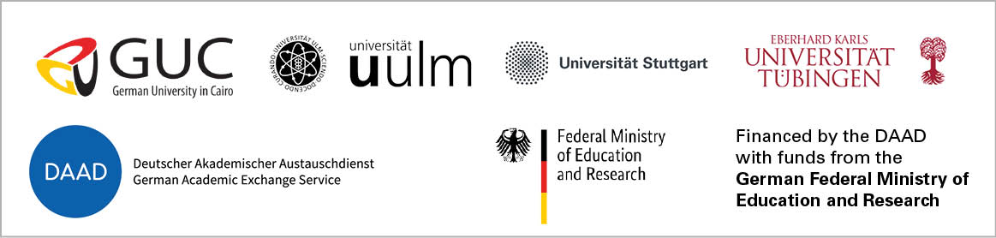

Research Proposal: BMBF funds in 2023
“Short Project Title”

GUC academic(s)
First and last name | Department | Email & Phone

German academic(s)
First and last name | Institution | Department | Email & Phone

1. Full Project Title / Research Areas (max. 1400 symbols including spaces, Calibri size 11)

2. Motivation and Project Goals (max. 3800 symbols including spaces, Calibri size 11)
3. Existing Previous Work / Cooperation and State of the Art (max. 3800 symbols including spaces, Calibri size 11)

4. Cooperation Partners, CVs go extra (max. 1800 symbols including spaces, Calibri size 11)
5. Project Implementation (max. 6200 symbols including spaces, Calibri size 11)
6. Expected output and long-term perspective (max. 1800 symbols including spaces, Calibri size 11)

